SATURDAY NIGHT KISS SET TO KICKSTART THORPE PARK’s 2020 LAUNCH

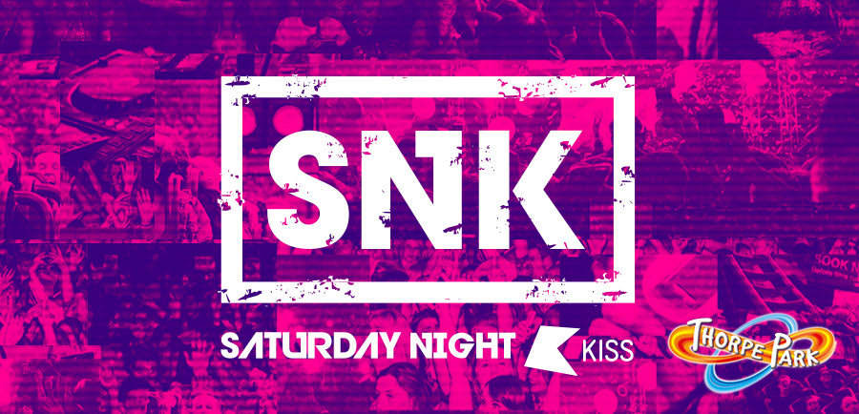

THORPE PARK is set to launch their 2020 season in style with KISS hosting their first ever Saturday Night KISS party at the Resort on 21st March from 7pm to 2am. Join us for a neon-themed launch party and help us kick start our season in style! Better still, for this unique event, the gates to the theme park are being thrown open a week ahead of the official re-opening on 27th March! Party goers will get exclusive access to a selection of the Resort’s top rides between 7pm-10pm for thrills after dark THEN tuck into some of the delicious food and drink available, before dancing the night away into the early hours from 10pm until 2am.

With 5.4m listeners a week across The KISS Network, Saturday Night KISS (SNK) is set to kickstart THORPE PARK Resort’s year of infinite thrills with KISS DJ’s Billy Da Kid, Tyler West, Scott Garcia and DJ Policy bringing the biggest floor-fillers and club tunes; with the biggest tunes and some of the top roller coasters ready and waiting, your Saturday night is covered!

Then when you simply can’t dance any longer, the THORPE SHARK Cabins is a hotel like no other and is ideally located on the Resort making it a convenient and affordable overnight stay like no other! With exclusive packages available for party guests* from just £40pp (based on four sharing) including an overnight stay, SNK party entrance tickets, a delicious breakfast for the morning after and free WIFI! So, don’t delay, grab your friends and book the ultimate night away today! Hotel packages will be launched very soon – keep an eye on our website and social channels for more information!

Entrance tickets to the SNK party are just £10pp*. As this is an exclusive event, tickets are limited and will be on a first come first served basis only. To avoid disappointment and to book visit www.thorpepark.com/KISS.

With over 30 thrilling rides, attractions and a whole host of brand-new immersive events launching throughout the season, THORPE PARK Resort is a UK destination alive like no other, and a must-visit for those looking to share endless fun with friends and family.

THORPE PARK Resort is open from 27 March to 1 November 2020***. Visit www.thorpepark.com for more information and to book tickets. Park tickets from £33 when booked in advance online****. Or for multiple visits throughout the season, why not consider a Standard Thorpe Park Season Pass available online in the sale currently for just £49 with the price including an unlimited use Digi-pass*****.

Visit https://www.thorpebreaks.co.uk to book a short break.

-ENDS-

*The event is strictly over 18’s only. Hotel guests must be aged 18 or over.
**
***Visit our website for details of opening dates and opening times as these vary throughout the season.
****When booked at least seven days in advance on our website. Subject to availability. On the day park ticket price £55.
***** Standard Season Pass includes free entry to non-event days, 20% Hotel Discount (through Merlin Holiday Club). Does not cover entry on Friday, Saturday or Sunday in August and first week of September, parking is not included. Free entry into FRIGHT NIGHTS is not included. Standard Season Pass cost from £55 outside of offer period. Please see the website for more details. Premium Season Passes also available and in the sale currently.

For more information please contact:
thorpepark@popcornpr.co.uk
01494 413170

Notes to Editors

ABOUT KISS
The KISS Network (KISS, KISSTORY and KISS Fresh) is a multi-media entertainment brand engaging with 16m people across its platforms and driving 5.4m listeners a week via its on-air radio platform.

From the mainstream to what’s new and different, KISS connects with its audience through its multi-platform strategy of presenting content around the music they love and the stuff they’re into, whenever and however they want it.

Playing the freshest new beats to old skool anthems, The KISS Network is also home to five breakout standalone music brands, the UK’s most listened to digital station KISSTORY (old skool & anthems) and KISS Fresh (non-stop new beats) plus brand new digital stations KISS Garage, KISS Dance and KISS Jams serving audiences with the specific music genres they love. KISS also gets out and about with the audience and hosts over 100 events a year in the UK and abroad from KISSTORY in Ibiza and Marbella, KISSTORY Festival in London, to KISS Pool Parties in Mallorca.

@KISSFMUK
www.kissfmuk.com

ABOUT THORPE PARK
Take on the towering skyline of Thorpe Park Resort with seven thrilling coasters with a combined height of over 650ft. Brace yourself against an average of 4.5gs per coaster and get ready to twist and turn through 22 inversions all at Thorpe Park Resort, Europe’s most intense theme park experience.
2020 will be see Thorpe Park enter another decade of immersive experiences and unmissable events for the whole family to enjoy! With an other-worldly season ahead, you can experience world class rollercoasters from the iconic Stealth, one of Europe’s fastest and tallest rollercoasters, to the UK’s only winged rollercoaster The Swarm. Endure the searing heat of Nemesis Inferno as you twist through the scorching forces and lava-laden loops of this intense and volatile volcanic voyage before getting a super-soaking from the 85ft plunge of Tidal Wave. Where else can you enjoy all of this alongside a variety of shows, attractions and brand-new events? Book your tickets in advance on our website and ensure you guarantee your entry to the most thrilling amount of fun you’ll have this year. www.thorpepark.com
Getting to Thorpe Park Resort
Thorpe Park Resort, Staines Road, Chertsey, Surrey, KT16 8PN
Train: Staines Station is just 32 minutes direct from London Waterloo
Bus: On open days a shuttle bus runs between Staines Station and Thorpe Park Resort every 15 minutes. Alternatively, both the 950 and 951 buses get you right up to the gates.
Follow us on social media:
@thorpeparkofficial
@THORPEPARK
THORPE PARK Official
THORPE PARK Resort

Thorpe Shark Cabins
Fastrack your thrills and unlock early access to the Island like no other with a jawesome stay at the Thorpe Shark Cabins – a hotel like no other! The unique hotel situated on the Thorpe
Park Resort Island features bite-sized rooms that sleep up-to four in a stunning waterfront location, only a fin away from Europe’s most thrilling coasters. After a thrill-packed day on Resort, Thorpe Shark Cabins are guaranteed to give even the most excitable sleeper a great night’s rest in smartly designed cabin-sized rooms. Along with jawesome exclusive unlimited Fastrack to the rides* until 11am on your second FREE day* in Park, you’ll also enjoy a hot buffet breakfast at our onsite restuarant, FREE WiFi and FREE car parking.
For more information visit THORPEBREAKS.co.uk

*Terms and conditions apply. Subject to availability. Fastrack entry is on selected rides only.

About Merlin Entertainments
Merlin Entertainments is a global leader in location-based, family entertainment. As Europe's Number 1 and the world's second-largest visitor attraction operator, Merlin now operates over 130 attractions, 19 hotels and 6 holiday villages in 25 countries and across 4 continents. Merlin’s purpose is to deliver memorable experiences to its 67 million guests around the world, through its iconic brands and multiple attraction formats, and the commitment and passion of its c.28,000 employees (peak season).

See www.merlinentertainments.biz for more information and follow on Twitter @MerlinEntsNews.

